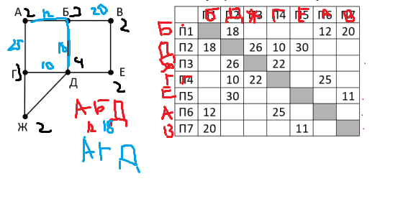

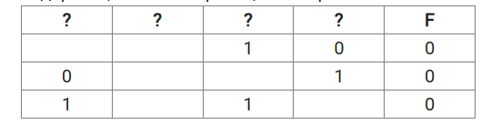

|  |  |  |  |  |
| --- | --- | --- | --- | --- |
| 2 | 3 | 1 | 4 |  |
| y | w | x | z | f |
| 0 | 0 | 1 | 0 | 0 |
| 0 | 0 | 1 | 1 | 0 |
| 1 | 0 | 1 | 1 | 0 |

_ _ _ _ _

